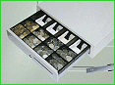 | CASH DRAWER - DFG1
Cash drawers: DFG1 Description: Metal cash drawer. Insert of ABS Plastic Any connector available upon request Dimensions: 485mm(L) - 423mm(B) - 112mm (H)
t
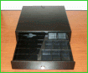 | CASH DRAWER - EURO MILANO B
 | Cash drawers: EURO MILANO B Description: Metal cash drawer. Insert of ABS Plastic Any connector available upon request Dimensions: 400mm(L) - 370mm(B) - 100mm(H)
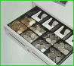 | CASH DRAWER - DFG2
 | Cash drawers: DFG2 Description: Metal cash drawer. Insert of ABS Plastic Any connector available upon request Dimensions: 415mm(L) - 410mm(B) - 100mm (H)
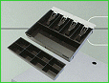 | CASH DRAWER - DFG3
 | Cash drawers: DFG3 Description: Metal cash drawer. Insert of ABS Plastic Any connector available upon request Dimensions: 405mm(L) - 350mm(B) - 90mm (H)
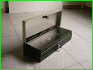 | CASH DRAWER - DFG5 - FLIP-TOP
 | Cash drawers: DFG5 (FLIP-TOP) Description: Metal cash drawer. Insert of ABS Plastic Any connector available upon request. Stainless steel model. Dimensions: 460mm(L) - 170mm(B) - 100mm(H)
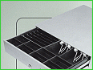 | CASH DRAWER - DFG 6
 | Cash drawers: DFG 6 Description: Metal cash drawer. Insert of ABS Plastic Any connector available upon request Dimensions: 420mm(L) - 423mm(B) - 1120mm(H) / 480mm(L) - 430mm(B) - 100mm(H)
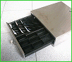 | CASH DRAWER - BABY
 | Cash drawers: BABY Description: Metal cash drawer. Insert of ABS Plastic Any connector available upon request Dimensions: 330mm(L) - 330mm(B) - 100mm(H)

